# Assignment 3

Yifan Luo, u7351505

## Task 1: Model Fitting with the Hough Circle Transformation

### Read RGB images and convert them into greyscale

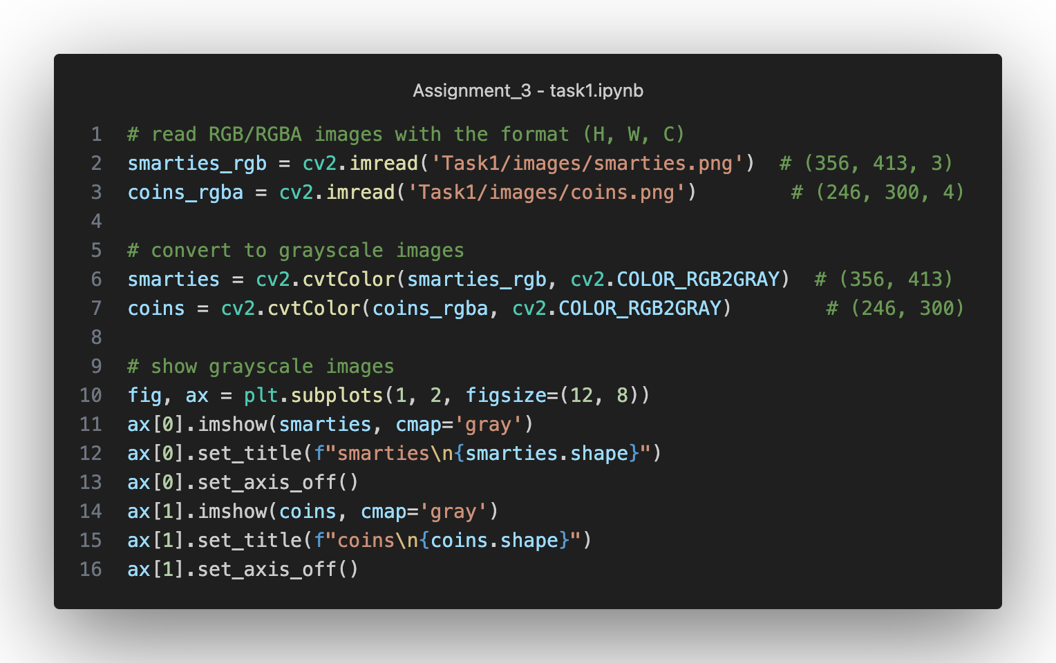

Figure 1 Read and convert images

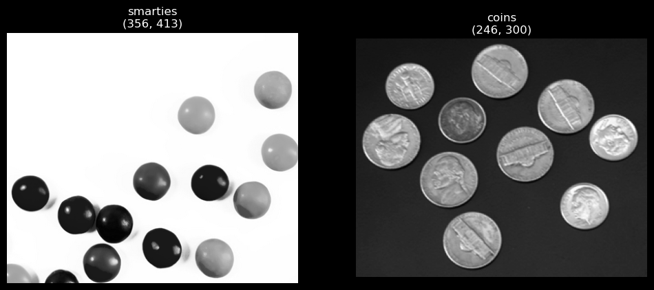

Figure 2 Grayscale images for Task 1

### Apply the Canny edge detector

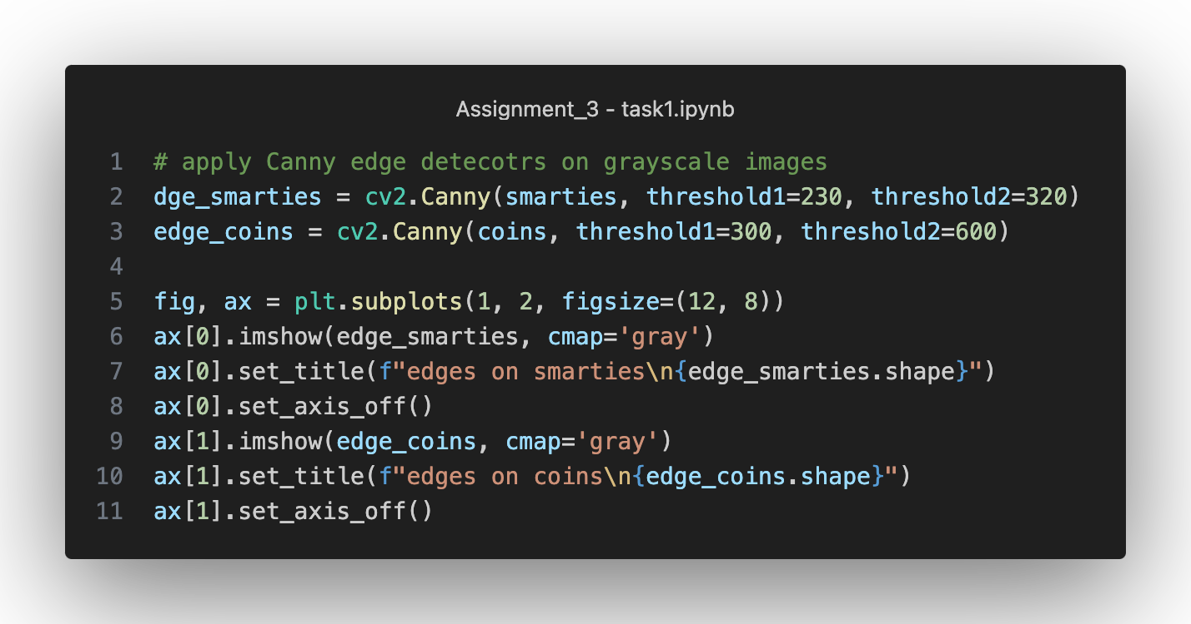

Figure 3 Canny edge detection

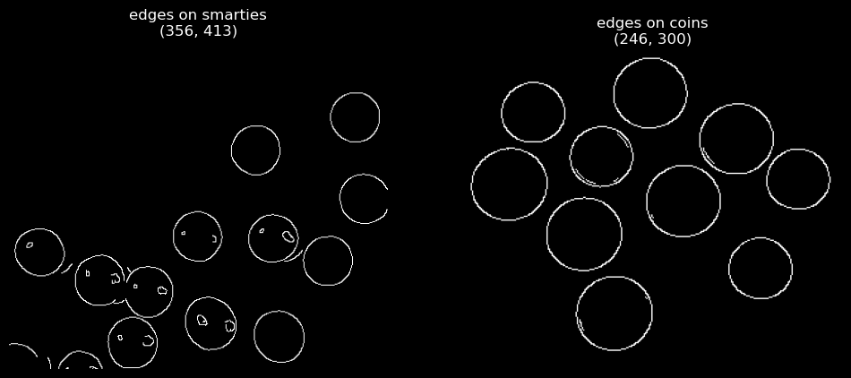

Figure 4 Results from Canny edge detectors

The screenshot above shows the “best” Canny edge detection results after trying multiple threshold combinations.

### Implement the Hough transform function

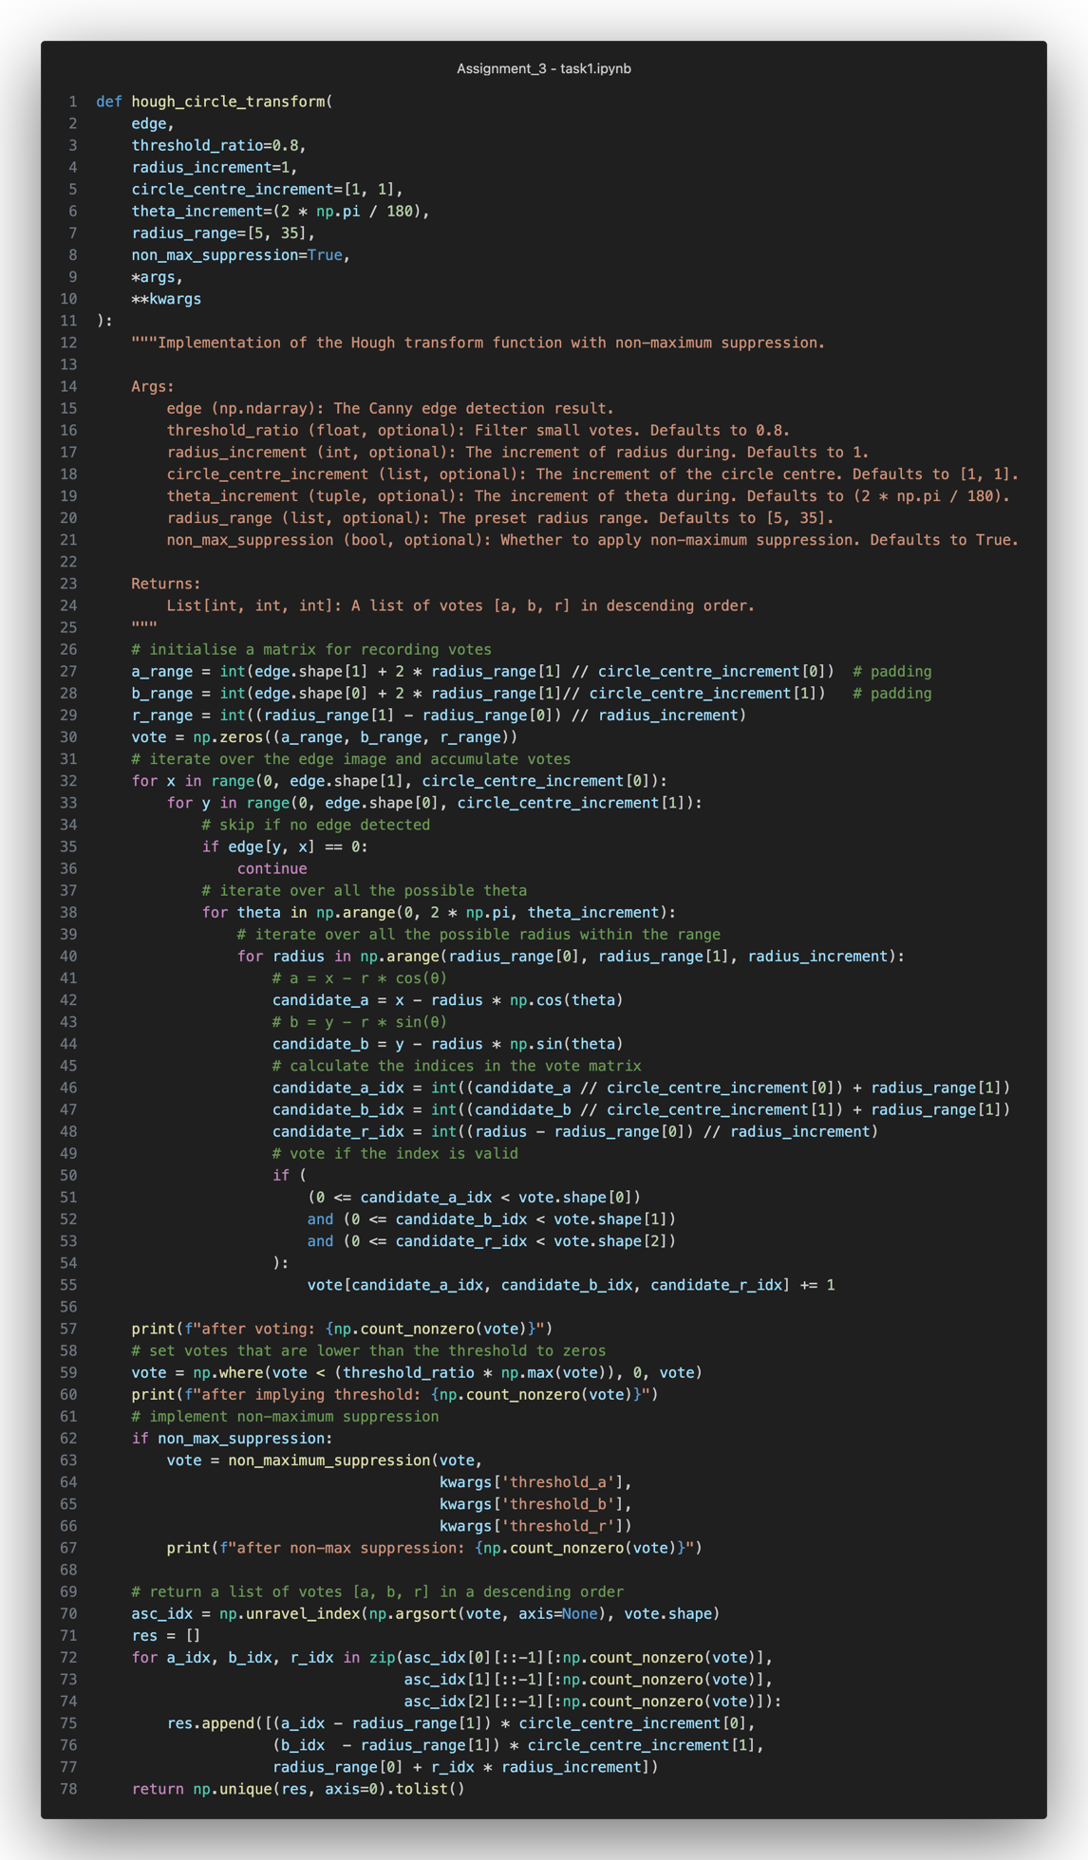

Figure 5 Implementation of the Hough transform function

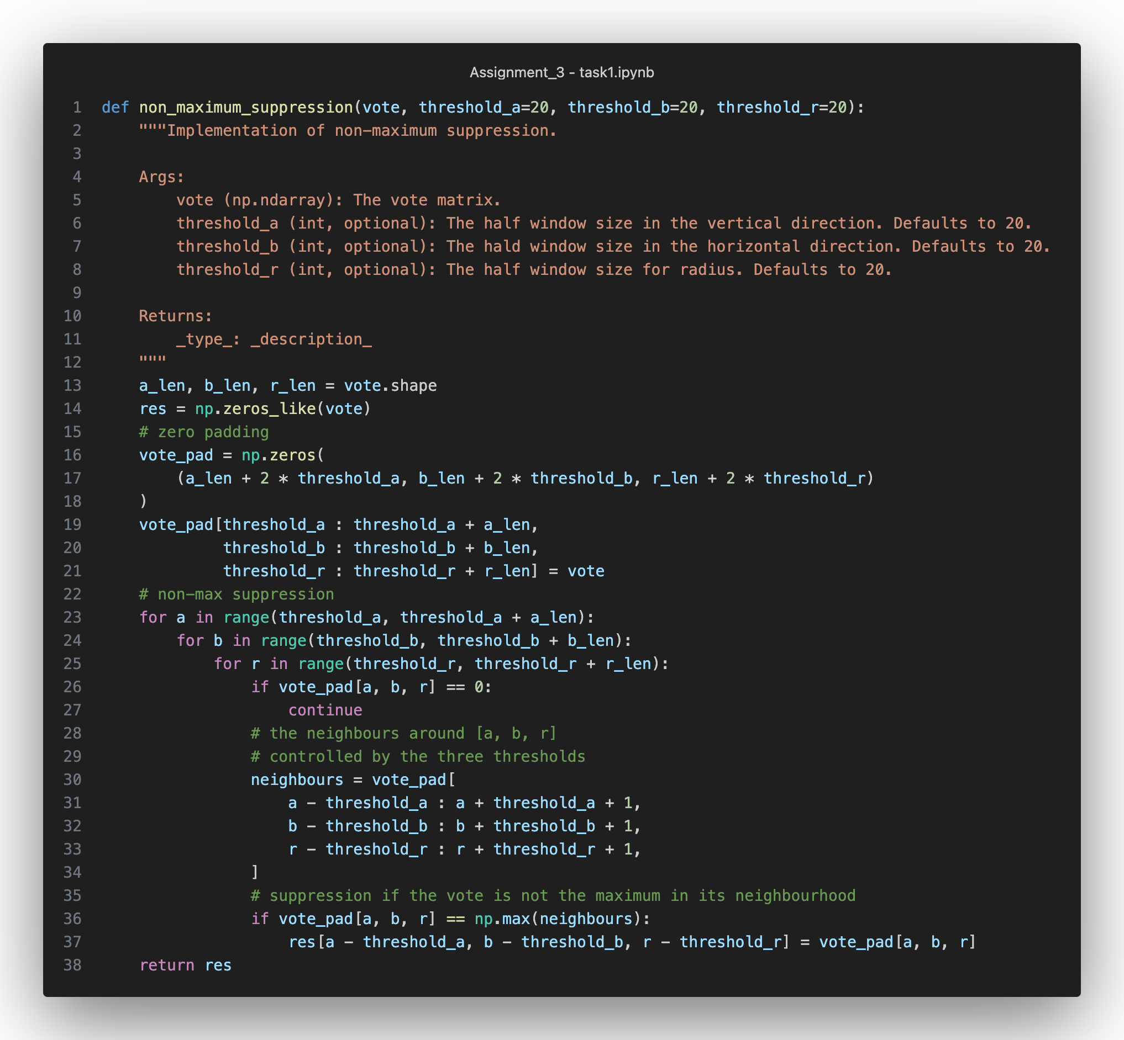

Figure 6 The non-maximum suppression in Hough transformation

Figure 5 shows the implementation of the Hough transformation based on the required interface. During the voting stage, in the search space, we only record the corresponding index instead of the real value. Notice that each iteration is controlled by a searching range and an increment.

After applying a threshold and non-maximum suppression, a list of circle candidates is filtered. Before returning the result in descending order, we need to transform the index from the voting matrix into the real [a, b, r] value.

### Design and implement a non-maximum suppression algorithm

The screenshot is shown in Figure 6 in the last task.

The function takes three thresholds to control the window size of its searching area. Especially, threshold_a (units of pixels) controls the neighbourhood in the vertical direction; threshold_b (units of pixels) controls the neighbourhood in the horizontal direction threshold_r (units of pixels) controls the searching range of radius. Non-maximum vote will be suppressed to 0 after comparing with its neighbourhood. Only local maxima of the designed neighbourhood are kept.

The function is called inside the hough_circle_transform function shown in Figure 5.

### Detect circles

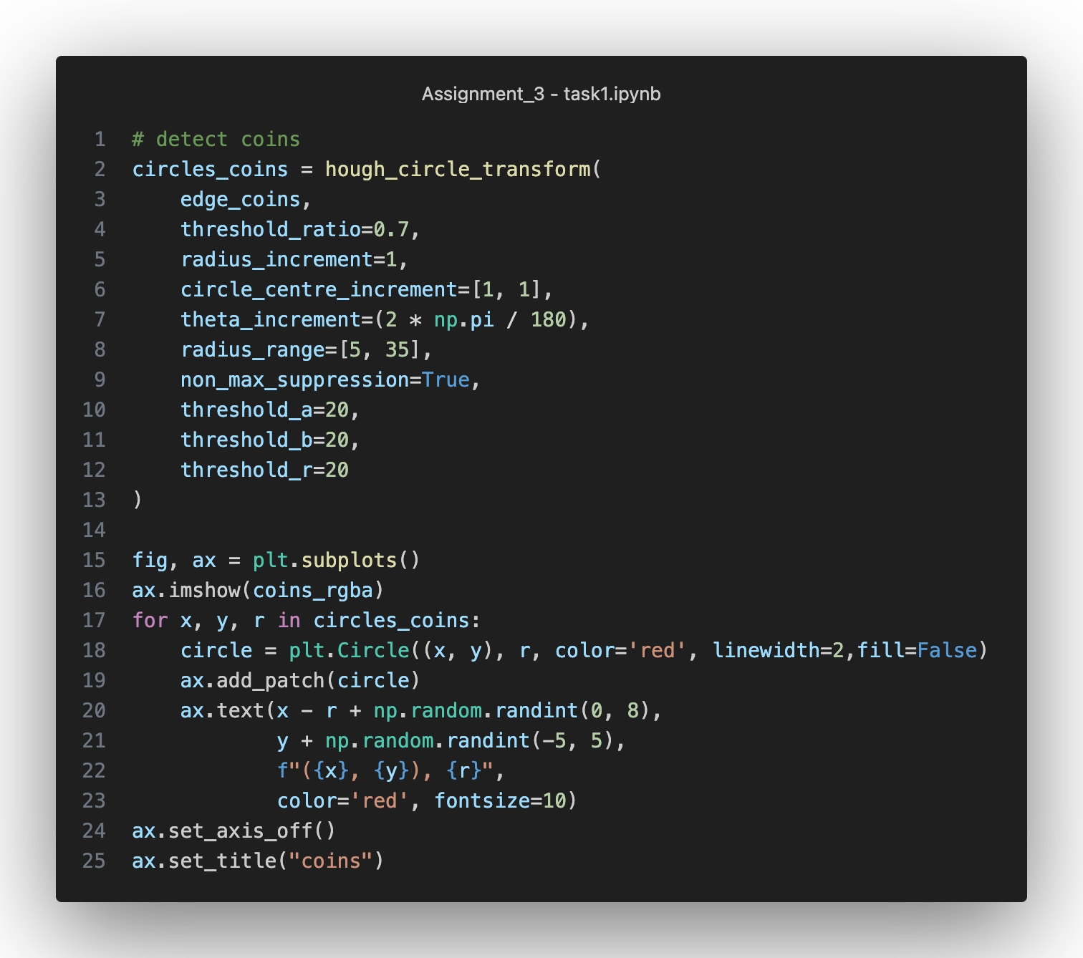

Figure 7 Detect circles on coins

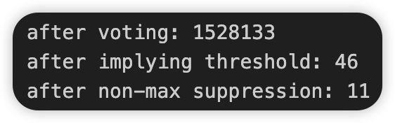

Figure 8 Circles during each stage

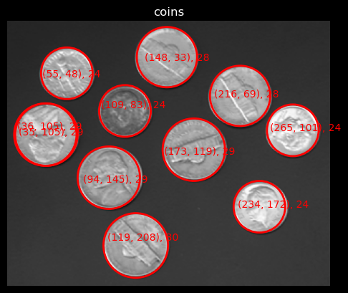

Figure 9 Circles on coins

There are 11 circles detected on the coins. The text over the coins shows the [a, b, r] value for each detection. Two circles are duplicated but are not been suppressed due to they have the same high votes.

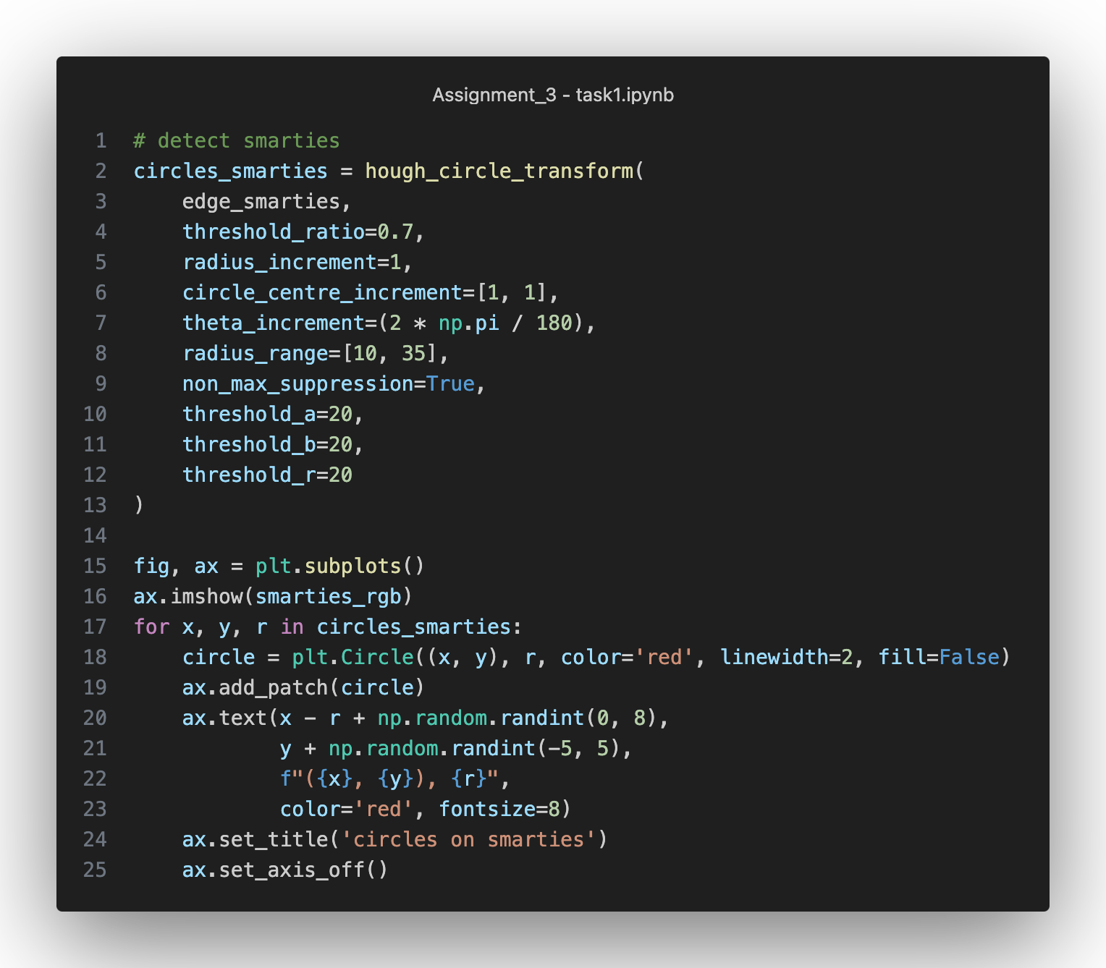

Figure 10 Detect circles on smarties

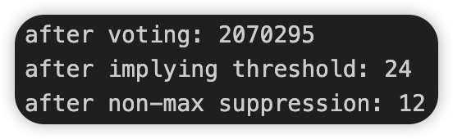

Figure 11 Detecting results during each stage

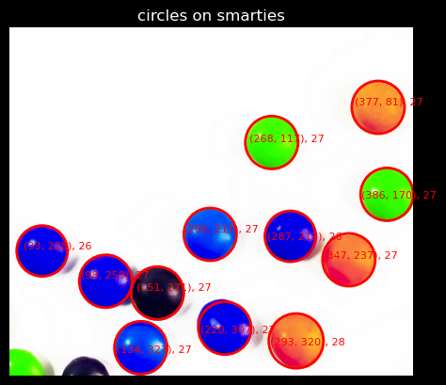

Figure 12 Circles on smarties

Similarly, the above three pictures show the results of smarties. Notice that the bottom-left smarties are not detected due to they have fewer votes and are filtered later by applying the threshold.

### Analysis the results

For coins:

There are 10 coins in the image as the ground truth. There are 11 circles detected at the end. All ground truths are detected, however, there is a duplicated circle overlayed on the same coin. Hence, FP = 1(the duplicated circle), FNR = 0 (all circles are detected), ACC = 10/11. The reason for the duplicates is that the votes of both circles are the same (89 and 89 shown in the below figure), and they cannot be filtered by applying the threshold or non-maximum suppression.



Figure 13 Top 11 votes in coins

For smarties:

There are 12 full smarties and 2 partial smarties (bottom-left corner) in total as ground truth. The 12 full smarties are all detected, while the 2 partial smarties are not detected. Suppose the 2 partial smarties are also considered as ground truth circles, then FP = 0 (all detected circles are true positive), FNR = 2 / 14 (the bottom-left corner circles are not detected). ACC = 1 (all detected circles are TP).

When using a smaller threshold (more detections) threshold_ratio = 0.1, threshold_a = threshold_b = threshold_r = 5, we can see the bottom-left corner circles can be detected:

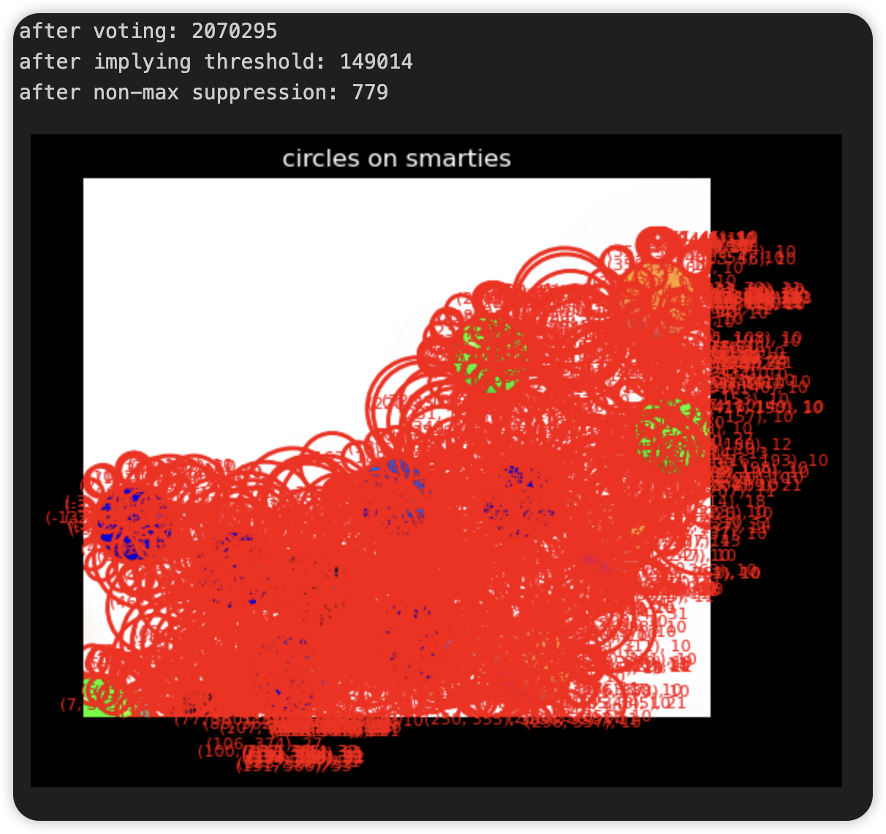

Figure 14 smarties with smaller threshold

After raising threshold_ratio to 0.3 while keeping all other parameters the same, the result shows that only one bottom-left circle is detected, while many false positive circles around other 12 smarlies:

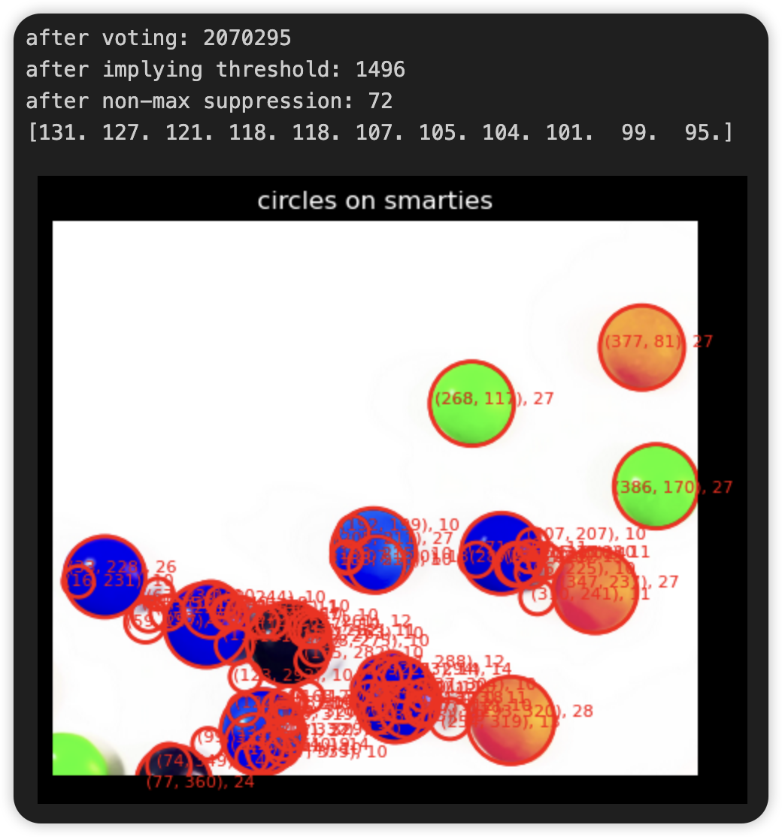

Figure 15 smarlies with larger threshold

When keeping the threshold_ratio as 0.1, and enlarge the threshold_a = threshold_b = 30 and threshold_r = 10, the result is:

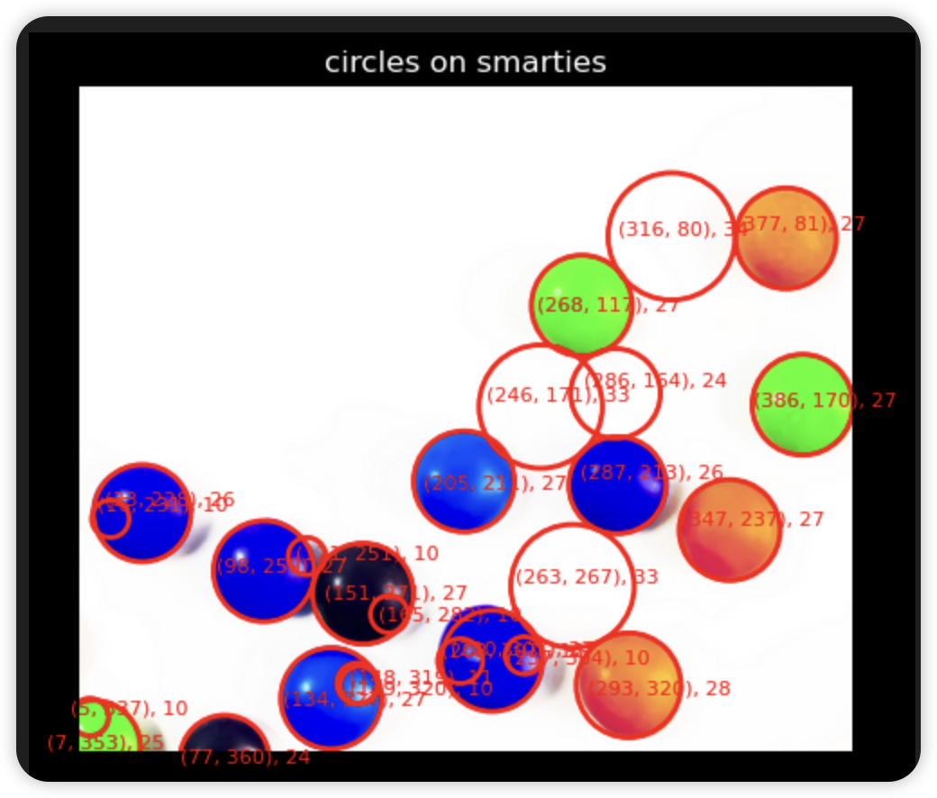

Figure 16 smarlies with large thresholds

Fewer FPs are detected on the 12 smarties, while the bottom-left corner circles are still detected.

Keep enlarging the threshold_r to 50 while keeping others the same, it shows a fairly good result:

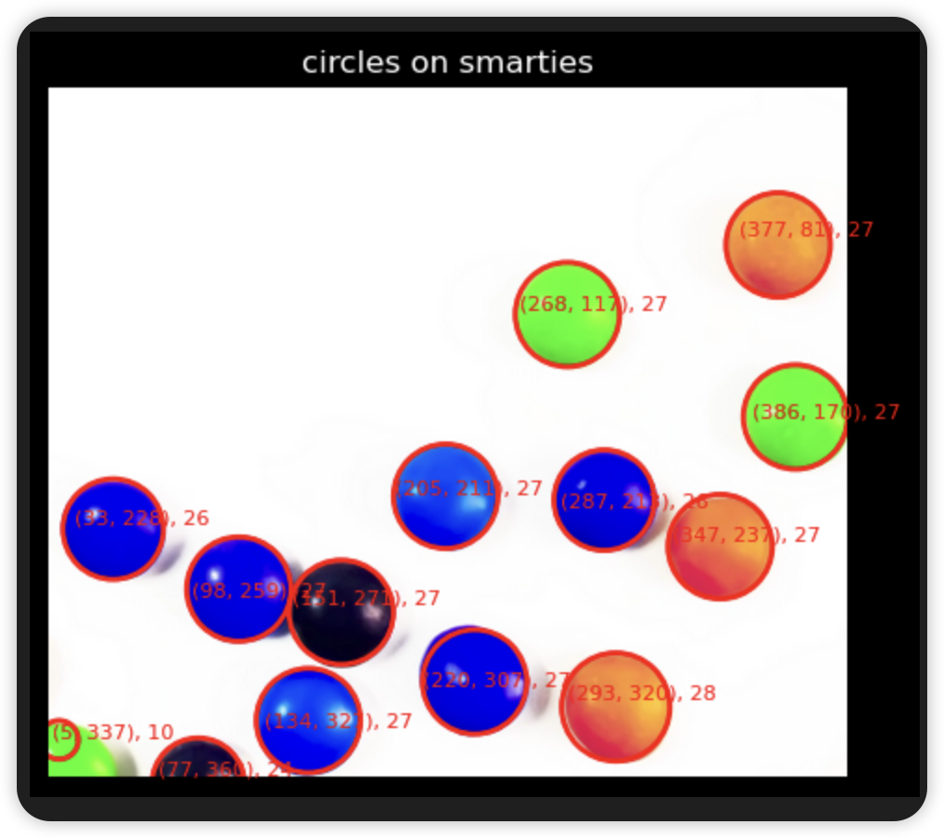

Figure 17 smarties with large thresholds

We can conclude that the bottom-left circles are been filtered by comparing them with the small FP circles overlayed beside them during non-maximum suppression.

From the above analysis and vacuolations, we see that finding a proper set of thresholds is sometimes time-consuming and needs to be tried multiple times to get fairly decent results. The more ground truth the picture has, the more combinations of thresholds we need to try. On the other hand, the complex the pattern is, the more combinations of thresholds we need to try.

### Examine the impacts of different parameters

Part of the analysis is included in the last question. In this question, we focus on other parameters inside the Hough transformation.

For coins, when setting a large threshould_ratio (0.9) without non-maximum suppression, while setting other increments as 1 unit of pixel and radius range [5, 35], fewer circles are detected:

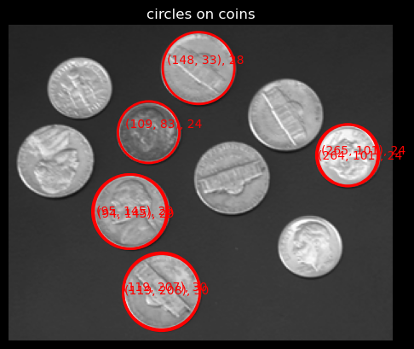

Figure 18 coins with threshold_ratio 0.9

After changing threshold_ratio to 0.4 while keeping others the same, more circles are detected:

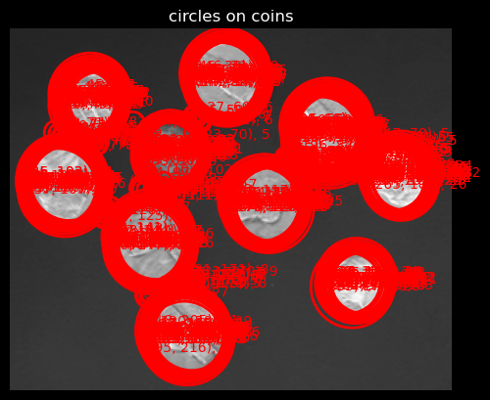

Figure 19 coins with threshold 0.4

We can easily conclude that, when threshold_ratio is set to a large number, only a few circles are left after applying the threshold. Some TP may be left because of improper threshold_ratio. Hence it is better to set it to a moderately small/large number to ensure it can select all TPs.

Now set threshold_ratio to 0.7, and all increments to 1:

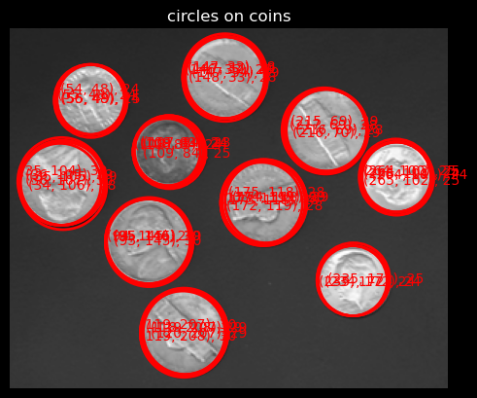

Figure 20 Coins with radius increment 1

When enlarging the radius increment to 3 while keeping others the same:

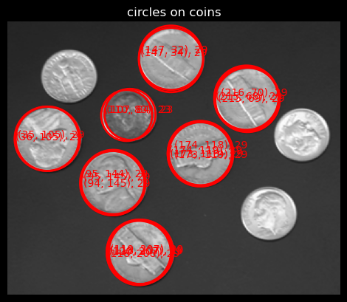

Figure 21 Coins with radius increment 3

Set radius increment to 10:

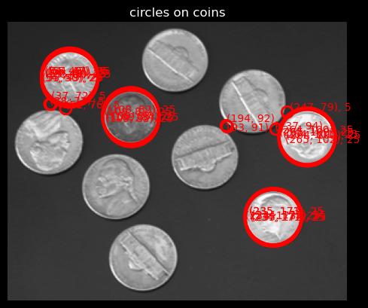

Figure 22 Coins with radius increment 10

We can conclude that the radius increment has a strong impact on the results. Different values may generate variant results (i.e., high variance). Hence, it is recommended to set it to a small value to detect all the possible TPs, while keep increasing it for a more efficient computation time.

Similarly, set the circle centre increment to [1, 1]:

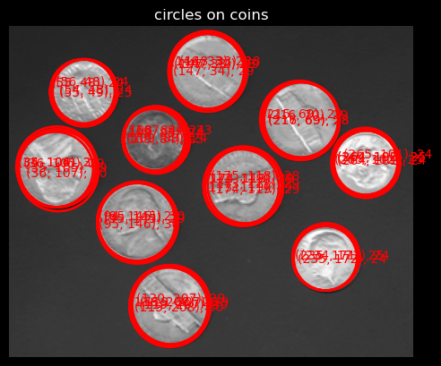

Figure 23 Coins with circle centre increment [1, 1]

Set it to [3, 3]:

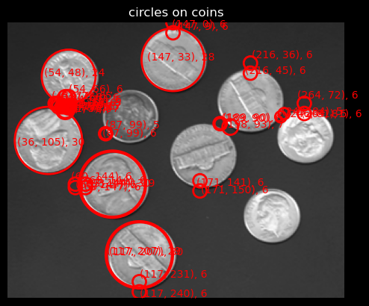

Figure 24 Coins with centre increment [3, 3]

Set it to [6, 6]:

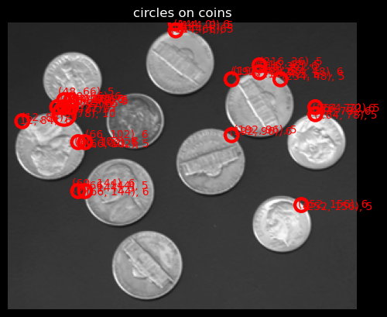

Figure 25 Coins with circle centre increment [6, 6]

We see that fewer circles are detected since the parameter space is getting smaller. It is recommended to set the value to a properly smaller value and increase it gradually to save more computation time.

When setting theta increment to 5*(2*pi/180):

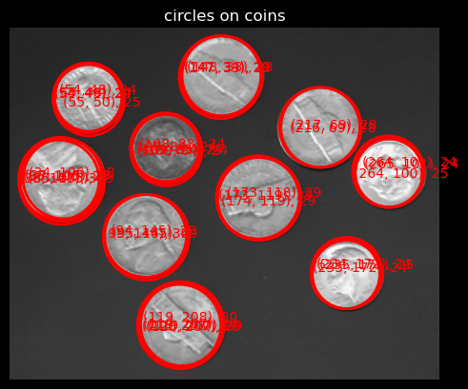

Figure 26 Coins with theta increment to 5*(2*pi/180)

Set it to 10*(2*pi/180):

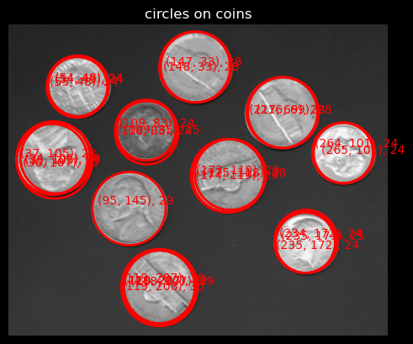

Figure 27 Coins with theta increment to 10*(2*pi/180)

We can see fewer circles are detected since the parameter space is getting smaller. . It is recommended to set the value to a properly smaller value and increase it gradually to save more computation time.

Now set threshold_ratio to 0.3, radius_increment to 5, other increments to 1, and threshold_a = threshold_b = threshold_r = 1:

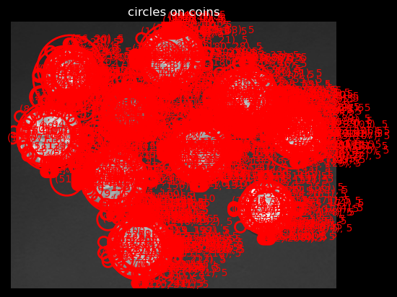

Figure 28 Coins with threshold 1

Set threshold_a = threshold_b = threshold_r = 5:

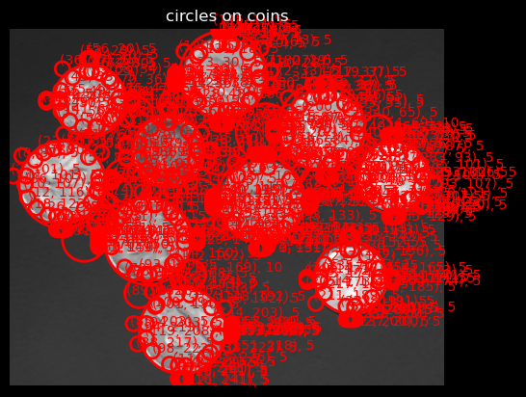

Figure 29 Coins with threshold 5

Set threshold_a = threshold_b = threshold_r = 20:

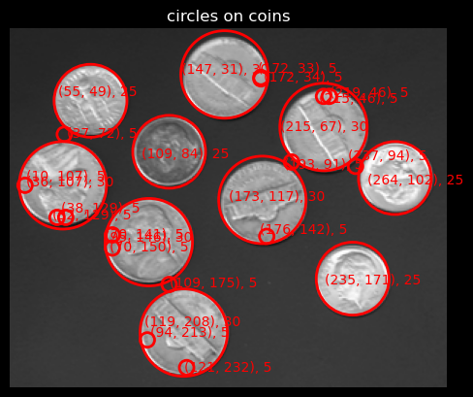

Figure 30 Coins with threshold 20

We can conclude that the larger the threshold, the larger the neighbourhood will be for each non-maximum suppression. It’s more recommended to use a large threshold after applying threshold and use non-maximum suppression to filter noises.

### Report the time and memory usage

For coins, when using threshold_ratio 0.9, radius_increment 1, circle_centre increment [1, 1], theta_increment 2*pi/180, radius_range [5, 35], threshold_a=threshold_b=threshold_r 20, the average running time in Jupyter Notebook is 28.32s.

For non-maximum suppression, the time complexity is O(a*b*r) where a, b, r are the shape of the vote matrix, i.e., the parameter space. The space complexity is also O(a*b*r).

For the Hough circle transformation function, the time complexity is O(H*W*theta*radius), where H and W represent the height and width of the image, and theta and radius represent each search space. The space complexity is O(a*b*r), where a, b, r represent each search space.

To optimise the algorithm:

* Instead of voting for every possible parameter combination, employ strategies like edge gradient-based voting or adaptive voting thresholds to prioritise more promising candidate circles.
* Calculation of different combinations of parameters can be accelerated by parallelisation.
* Using sparse sampling of accumulator space can also speed up the voting process while maintaining robustness.
* Using sparse matrices or compressed representations to store accumulator values and reduce memory usage.
* Techniques like thresholding accumulator values or early stopping criteria based on accumulated evidence can terminate voting for non-promoting circles early.

## Task2: Two-view Homography Estimation

### Read RGB images as NumPy arrays

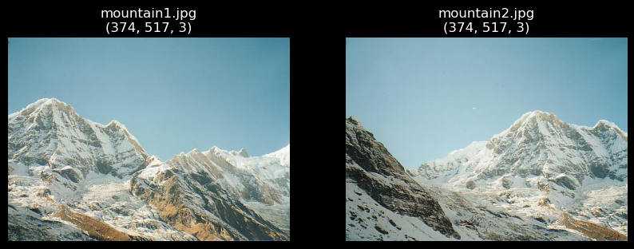

Figure 31 RGB images in Task 2

### Implement the homography function

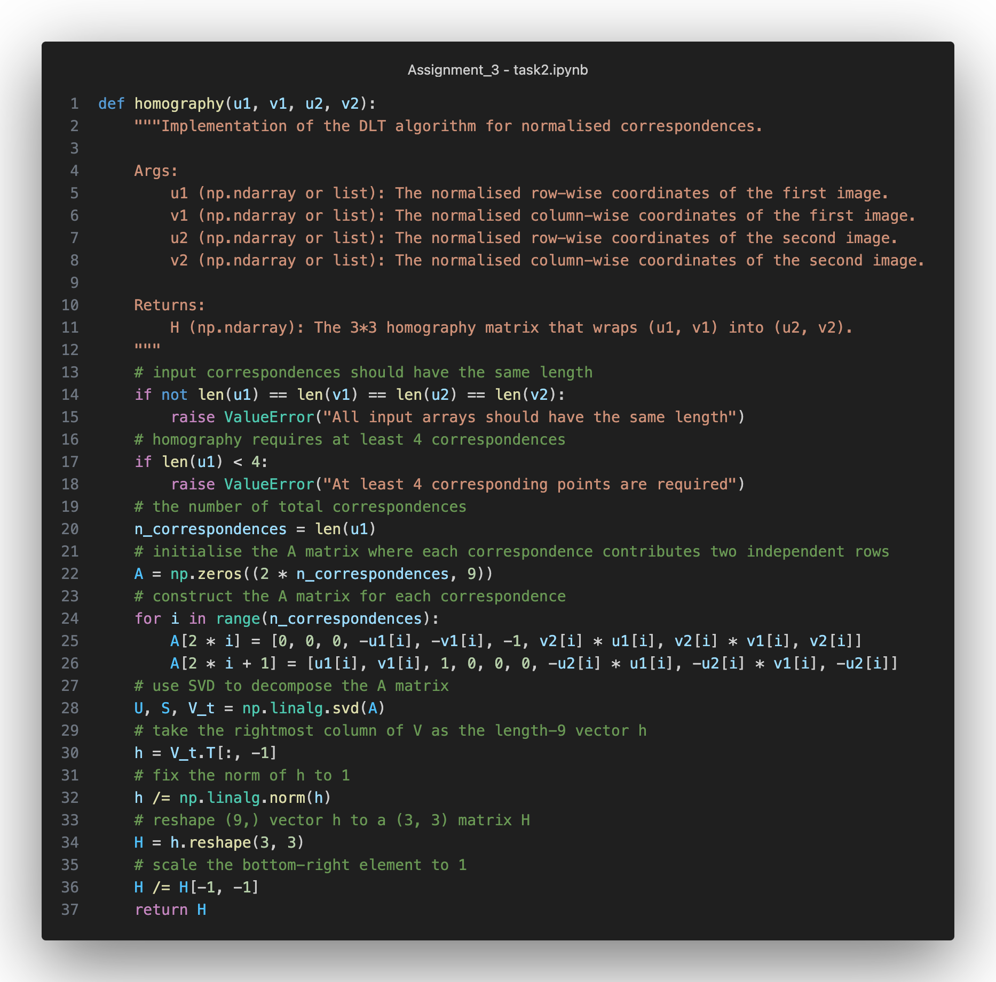

Figure 32 The homography function based on the described interface

The function takes normalised correspondences from both images and conducts an SVD decomposition on the constructed matrix A from all correspondences.

The returned homography matrix H is constructed from the last column of the decomposed matrix V, scaled its norm to 1. Notice that, according to conventions, H is divided by the bottom-right corner element to ensure its value equals 1.

### Implement the compute_normalisation_matrix function and the homography_w_normalisation function

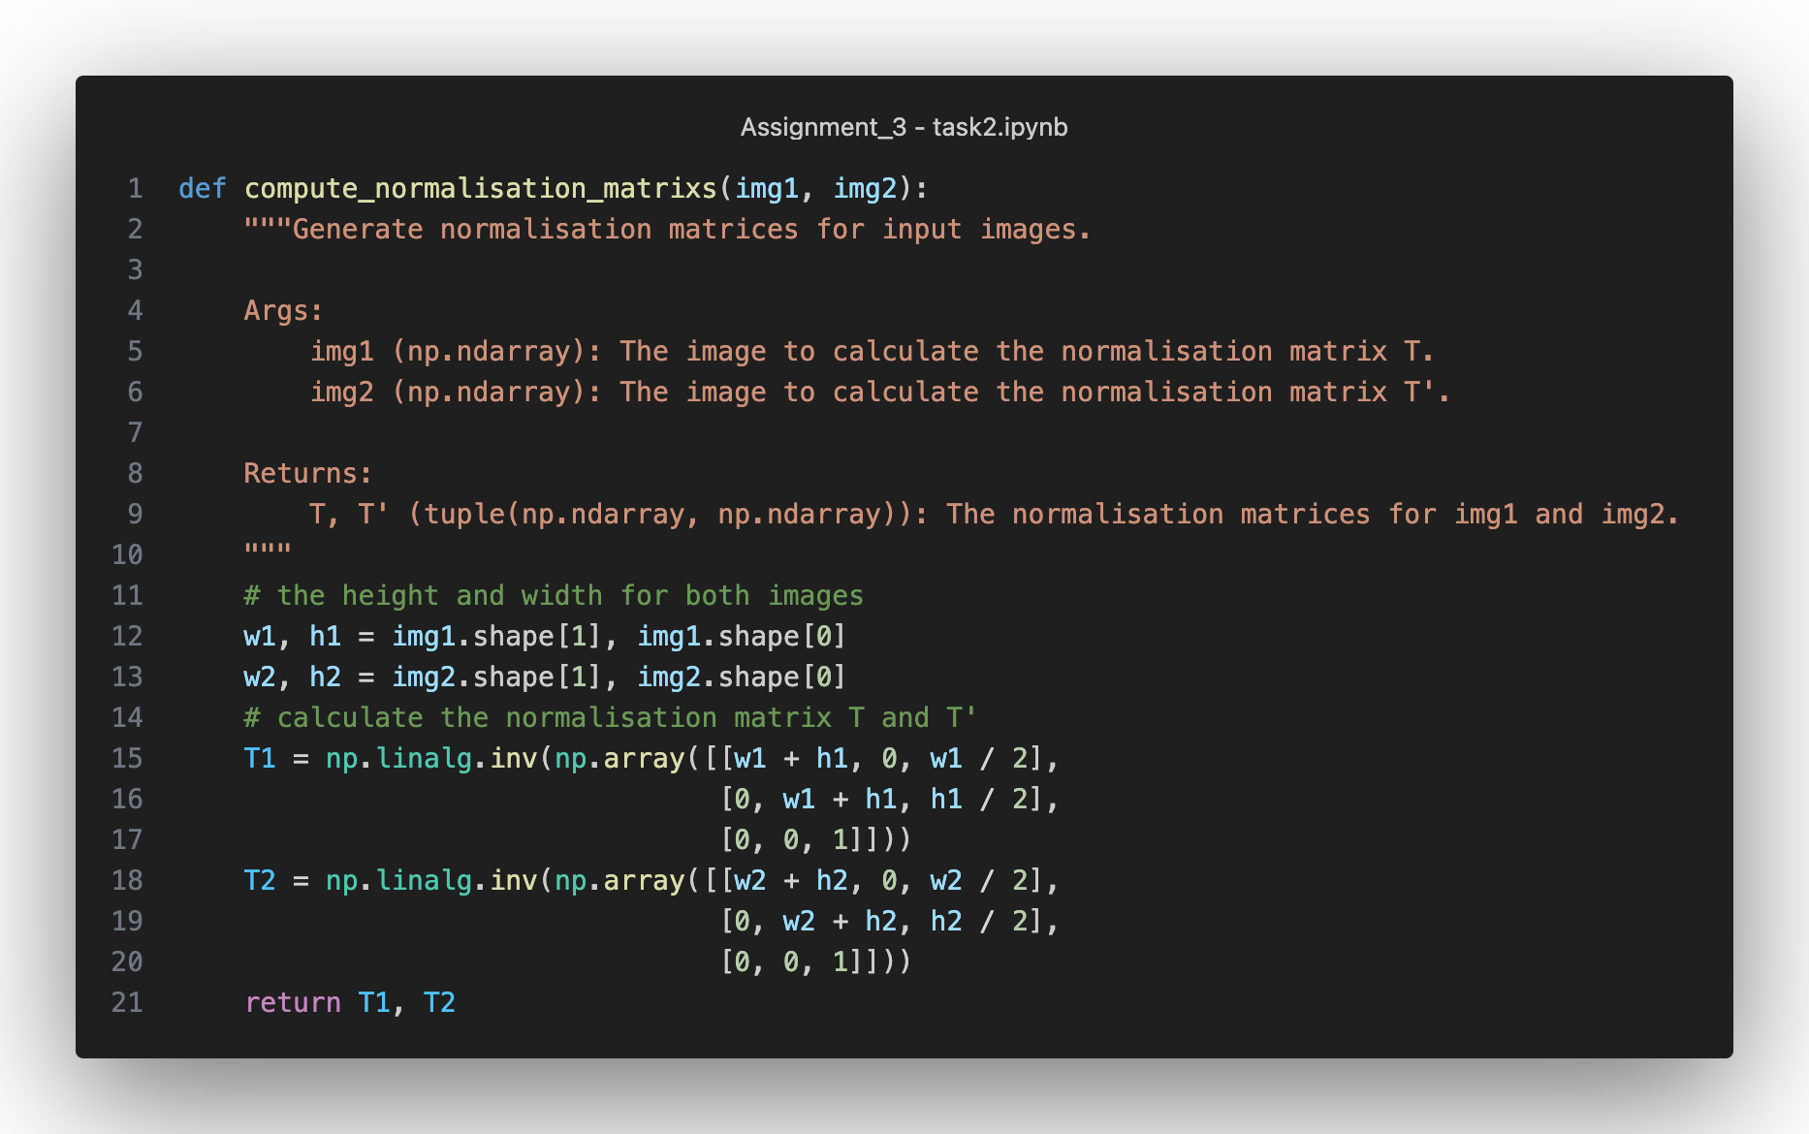

Figure 33 The compute_normalisation_matrix for computing normalisation matrices from input pictures

The screenshot above shows the implementation of calculating normalisation matrices T and T’ based on slides. The function returns calculated T and T’ for later use.

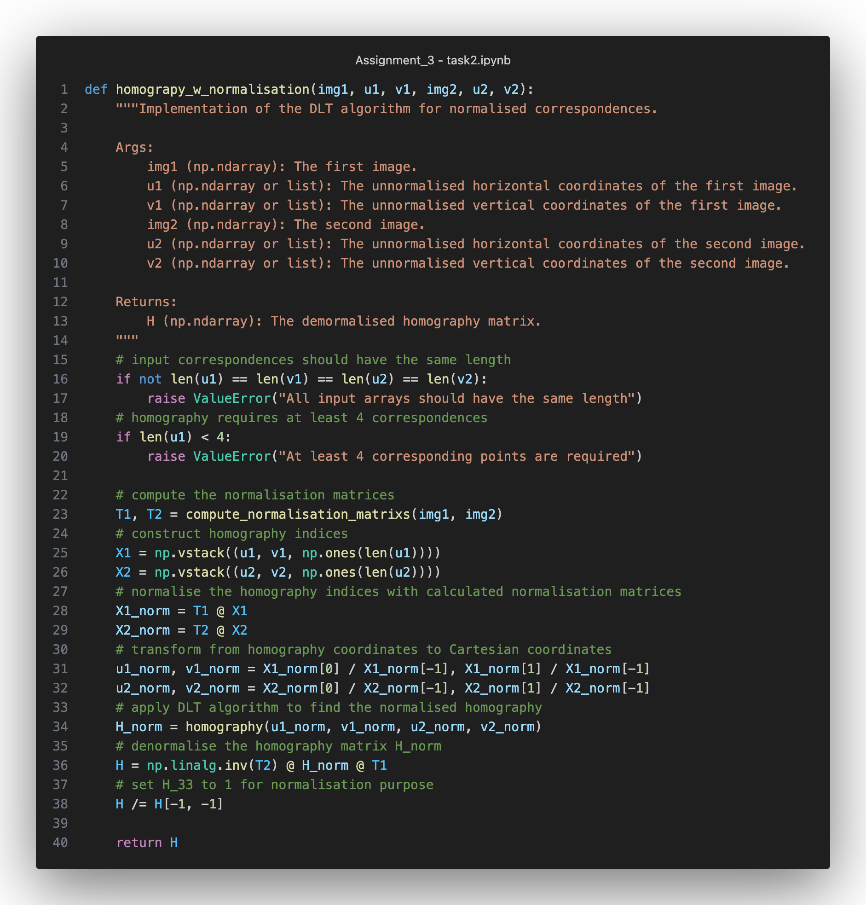

Figure 34 The homography_w_normalisation function to calculate unnormalised homography matrix H

The function above first calculates the normalisation matrices T1 and T2 by using the previous function compute_normalisation_matrix. Then, the unnormalised coordinates u1, v1, u2 and v2 are constructed and transformed into normalised coordinates using T1 and T2.

The homography function is used to calculate homography matrix with normalised coordinates u1_norm, v1_norm, u2_norm and v2_norm. Then, the homography matrix is denormalised by using T1 and T2 and scaled by using the bottom-right corner entry.

### Use SIFT keypoint detectors and feature descriptors to find correspondences

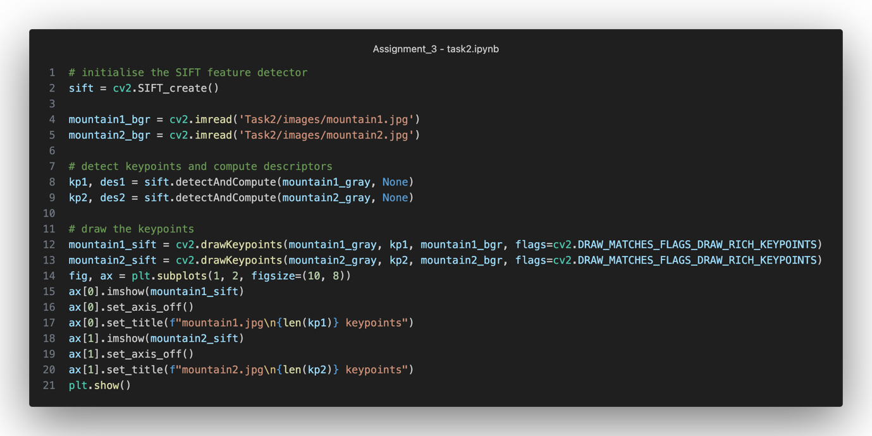

Figure 35 Use SIFT to find keypoints and descriptors

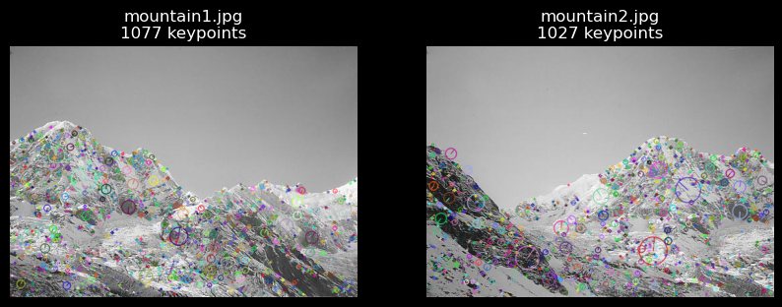

Figure 36 The detected keypoints from both images

First, read the original images in BGR and grayscale formats. Then, use cv2.SIFT_create() to create SIFT detectors and find keypoints (kp1, kp2) and descriptors (des1, des2) for mountain1 and mountain2. The results show mountain1 has 1077 keypoints and mountain2 has 1027 keypoints.

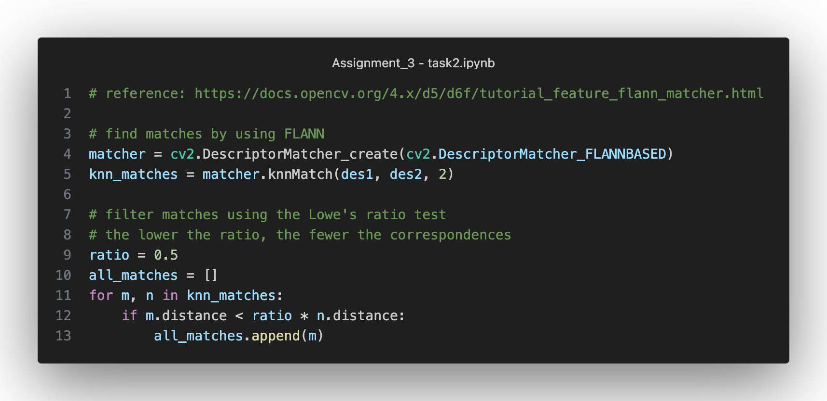

Figure 37 Match and select correspondences with a threshold

The figure above shows how to use a matcher to match keypoints in OpenCV. Notice that we use a ratio of 0.5 as a threshold to select from all the correspondences. The lower the ratio, the fewer the matches.

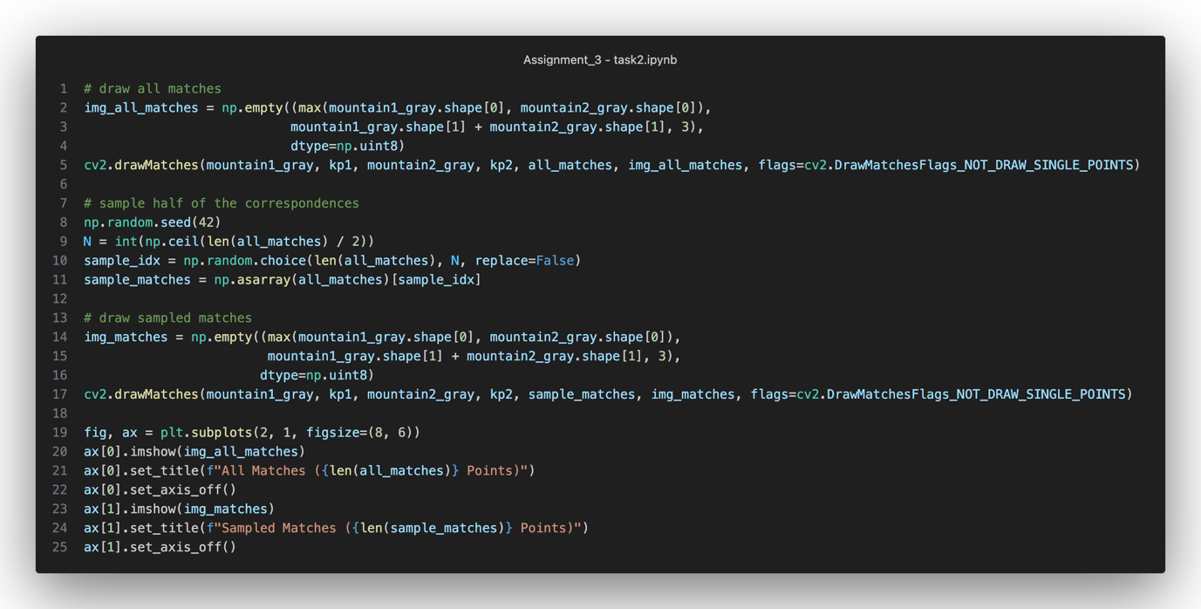

Figure 38 Draw all the matches and the selected matches by using a seed 42

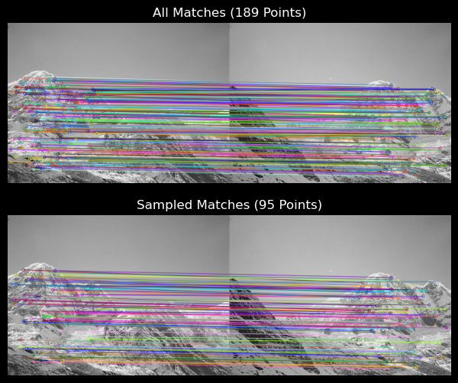

Figure 39 The all matches and the selected matches

There are 189 matches under the ratio of 0.5, and 95 selected matches according to the requirement.

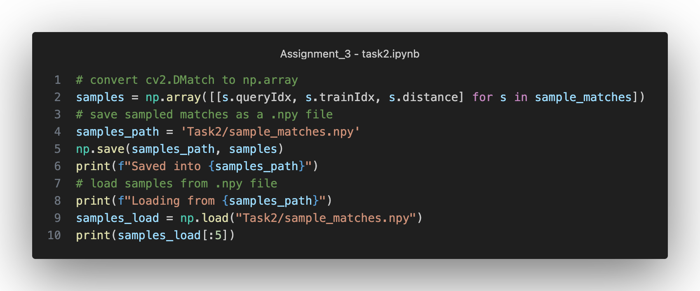

Figure 40 Save and load from a "npy" file

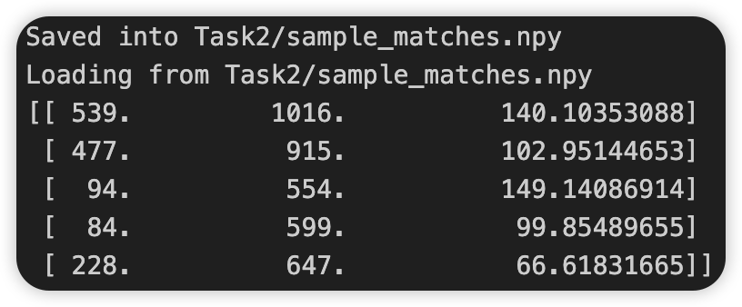

Figure 41 The NumPy array loaded from the "npy" file

A “.npy” file is saved for the NumPy array object which contains the coordinates of matches from OpenCV. The above picture shows the array information of the first 5 matches. The first column is the query index for mountain1, the second is the target index for mountain2, and the last is the distance of each match.

### Implement homography_w_normalisation_ransac

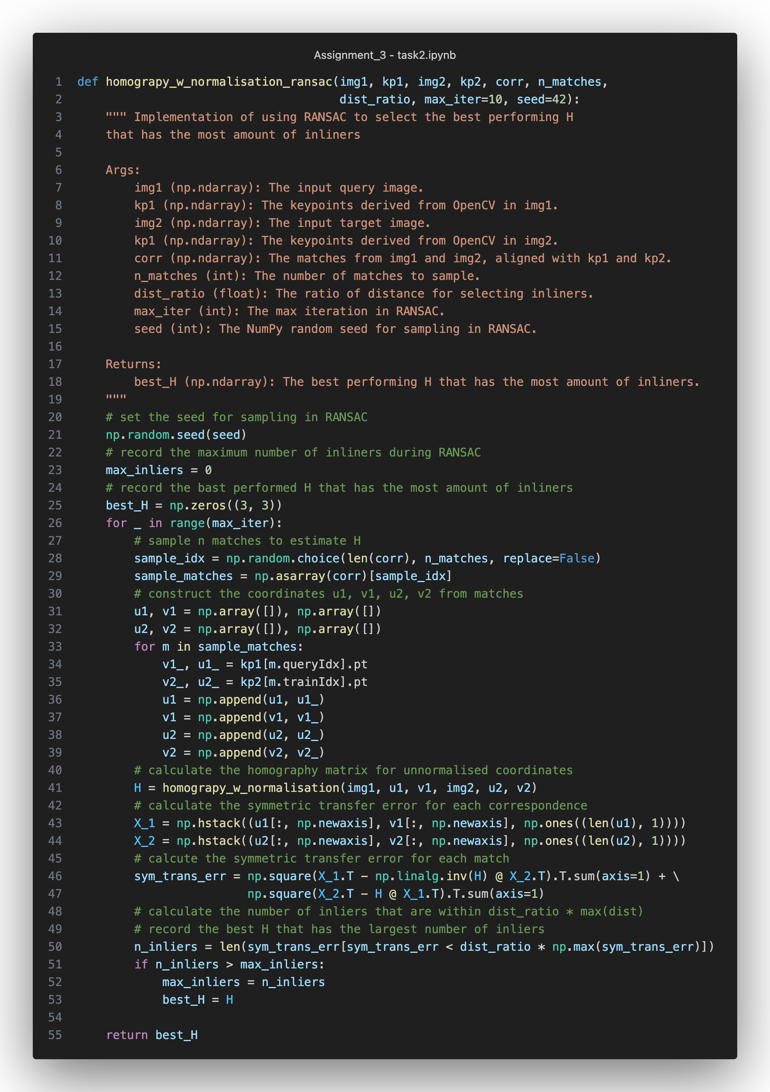

Figure 42 The homography_w_normalisation_ransac function to select the best performing H using RANSAC

The screenshot above shows the implementation of using RANSAC to select the best H. In each round, the algorithm samples several matches and uses these matches to calculate a homography matrix H. We use symmetric transfer error and a distance ratio for each match to select inliers. Record and return the best-performing H at the end.

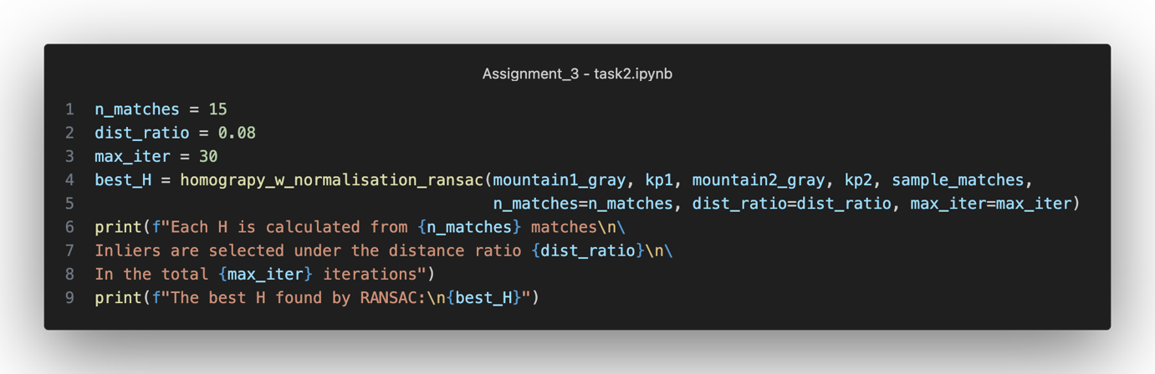

Figure 43 Show the best performing H

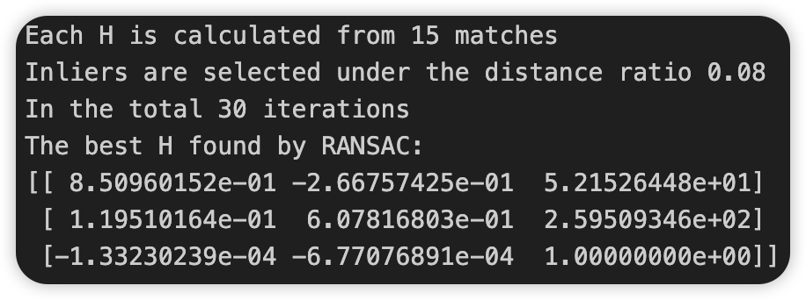

Figure 44 The best H found by RANSAC

The result shown above is the best-performing H found by RANSAC. In the total 30 samplings, each H is calculated using 15 sampled matches (set seed to 42), and the liners were selected with a distance (symmetric transfer error) threshold of 0.08.

### Warp and stitch the results

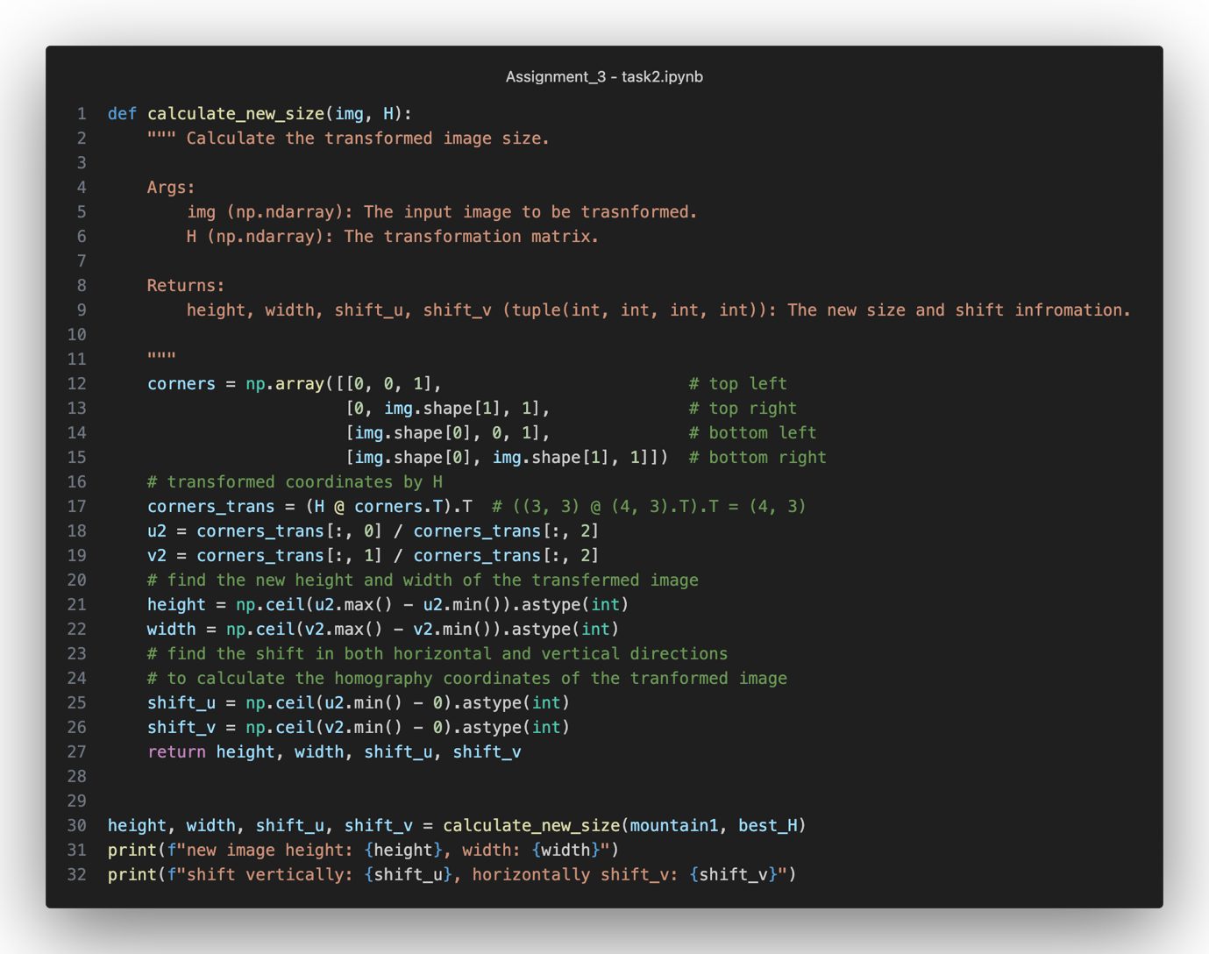

Figure 45 The function used to calculate the new size and shift information for inverse wrapping

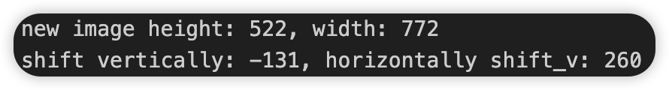

For mountain1, the transformed image size has a height of 522 and a width of 772. The shift information is used in the later inverse warping with the bilinear interpolation technique.

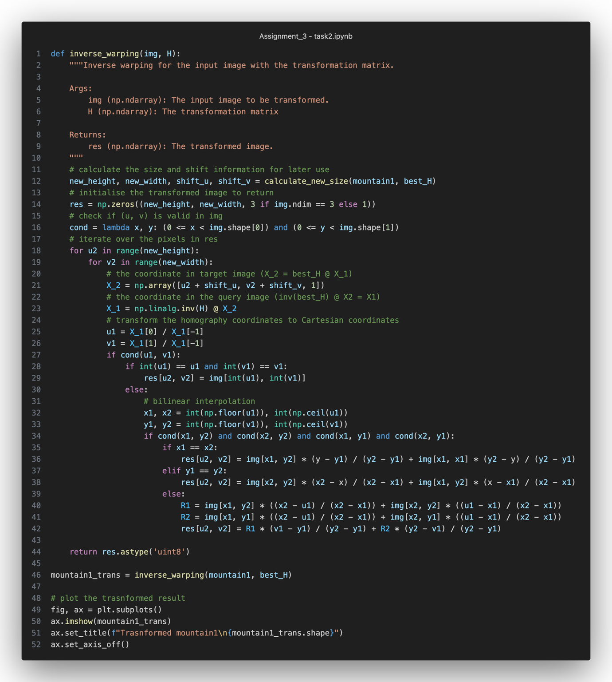

Figure 46 Inverse warping for mountain1

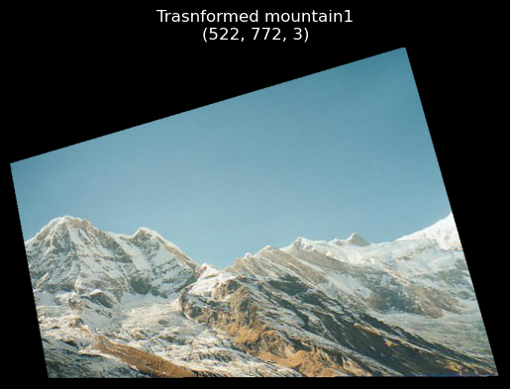

Figure 47 The transformed mountain1

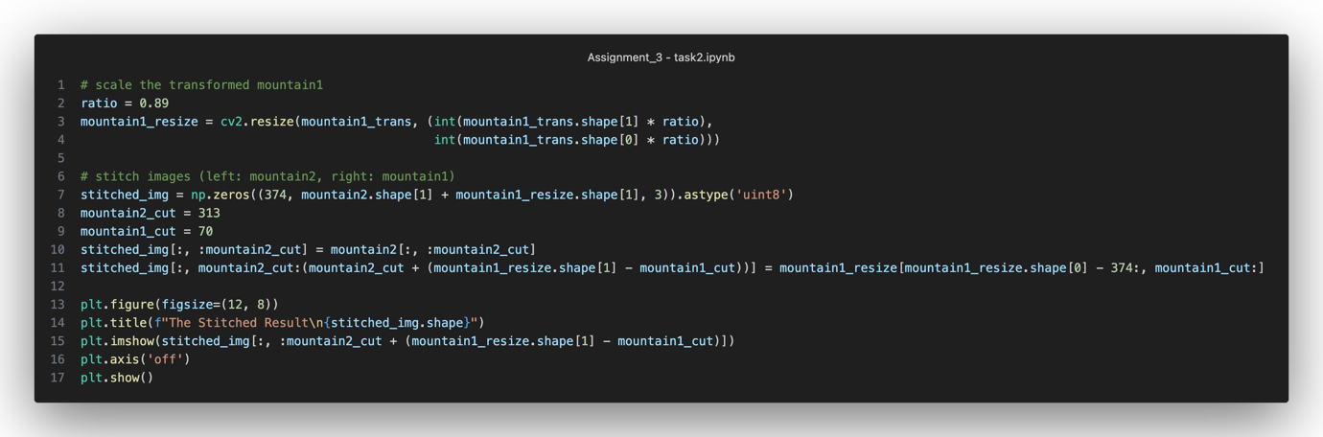

Figure 48 Stitch two images

The stitching process includes scaling for mountain2. The stitch points from both images are selected based on the visual results from the previous SIFT keypoints and descriptors.

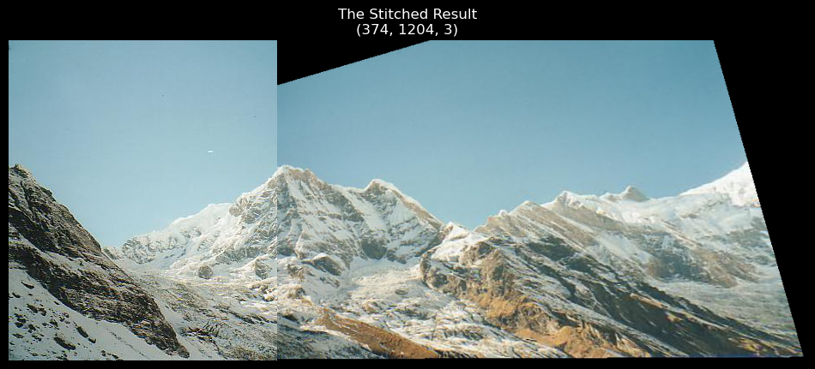

Figure 49 The stitch result (left: mountain2, right: mountain1)

### Discussion

First, we use ginput() to select 8 correspondences from both images and save the correspondence coordinates into “point_1.npy” for mountain1 and “point_2.npy” for mountain2.

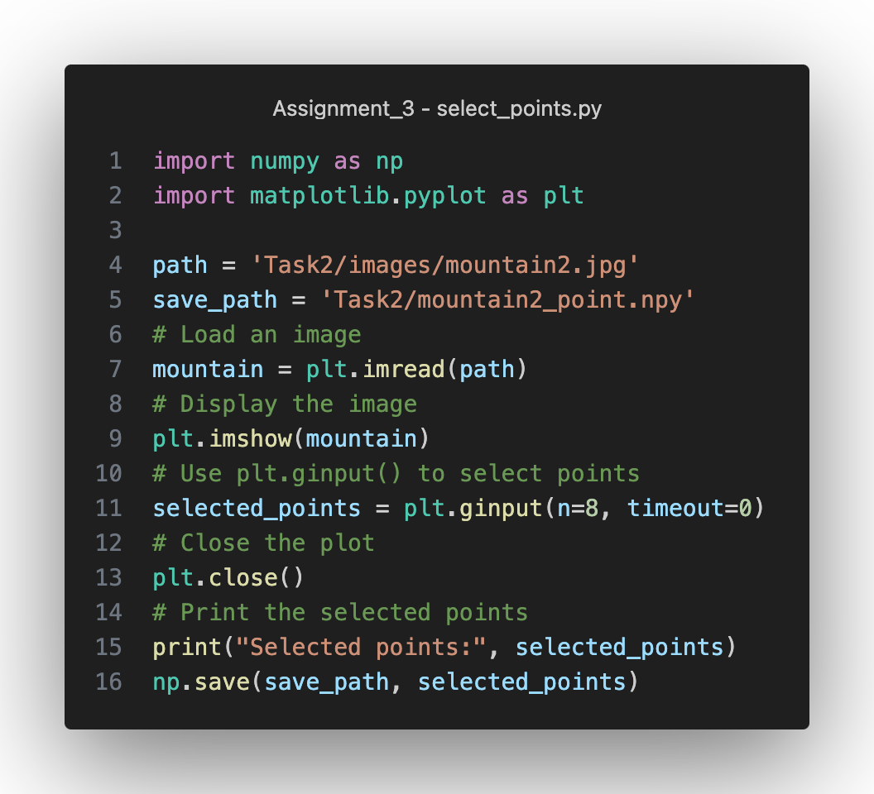

Figure 50 Select 8 correspondences

The manually selected correspondences are:

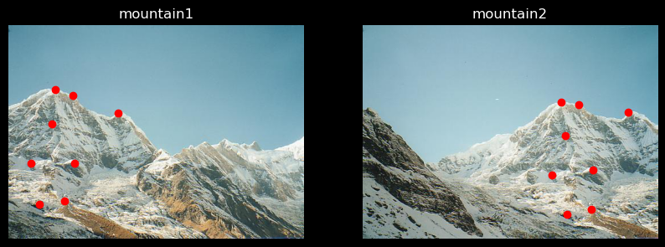

Figure 51The manually selected correspondences

Use homography_w_normalisation to calculate the homography matrix:

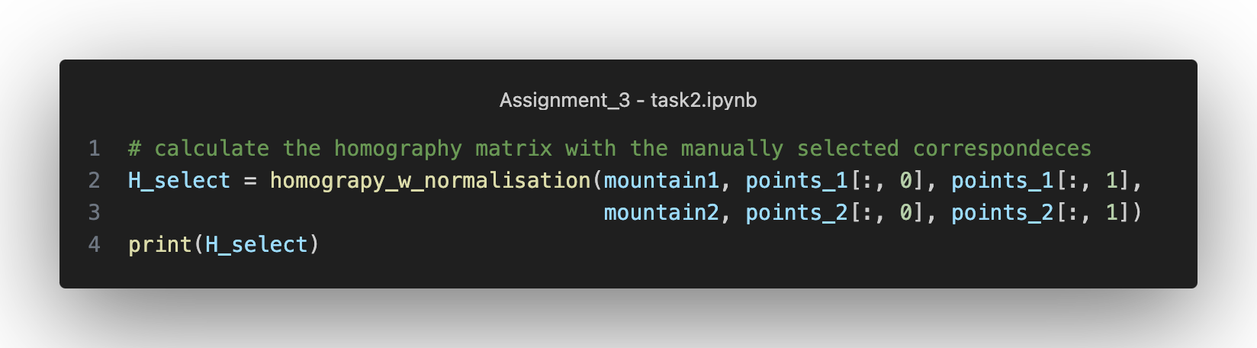

Figure 52 The homography matrix calculated with the 8 correspondences

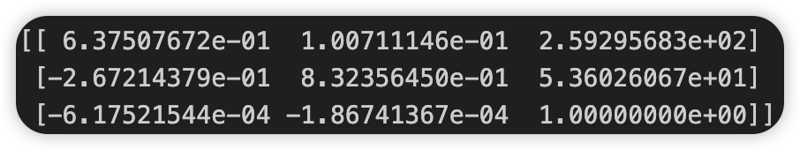

Figure 53 The calculated homography matrix

Compared with the results (RANSAC) in Task 2.5, some entries have significant differences.

The following plot shows the stitch results by using the manually selected correspondences. Notice that we use the similar stitch location as the previous one for a better comparison:

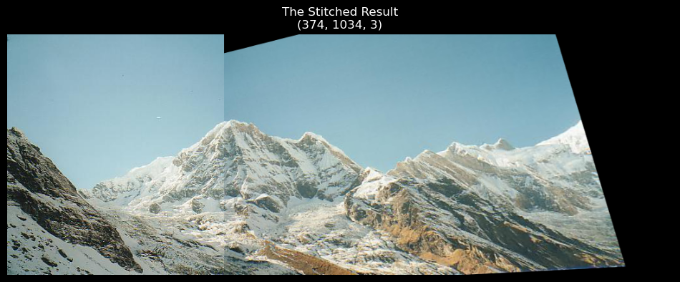

Figure 54 The stitch result from manually selected correspondences

Visually, the new stitch result is more accurate, especially around the stitch line.

**Theoretical analysis:**

* Biased model assumption: The homography estimation tasks normally assume a planar scene and a pinhole camera model. If the scene is not strictly planar, the estimated homography may introduce bias, especially in regions where the scene deviates from planarity.
* Improper optimisation method: Some homography estimation techniques rely on optimisation methods like RANSAC or least squares. Some methods may converge to local minima or be sensitive to outliers, which result in biased estimates if not appropriately handled.
* Parameterisation: The choice of parameterisation for representing the homography matrix can introduce the estimation bias, such as under-parameterisation or over-parameterisation.
* The distribution of correspondence: The distribution of correspondences significantly influences homography estimation. A uniform distribution allows for accurate estimation across the entire scene, while clustering, outliers, sparse distributions, and non-uniform scales can introduce biases and affect the reliability of the estimated homography.

**Empirically analysis:**

* Noise in correspondences: Homography estimation methods are sensitive to noise in correspondences between image points. When there are outliers in the correspondences, the estimated homography tends to be biased towards the outliers.
* Insufficient correspondences: Normally, a homography requires a minimum number of correspondences. Insufficient correspondence may be biased due to the limited information available.
* Lens distortion: Homography estimation typically neglects lens distortions. In real-world scenarios, lens distortions can introduce bias, especially in wide-angle lenses or fisheye cameras.
* Scale ambiguity: Homography estimation alone cannot determine scale, leading to scale ambiguity.
* Inaccurate camera calibration: Homography estimation relies on accurate camera calibration parameters. Errors in camera calibration, such as inaccuracies in focal length or principal point estimation, can propagate into biased homography results.